- \Operation\IPC/bulkware ejection\IPC/bulkware ejection
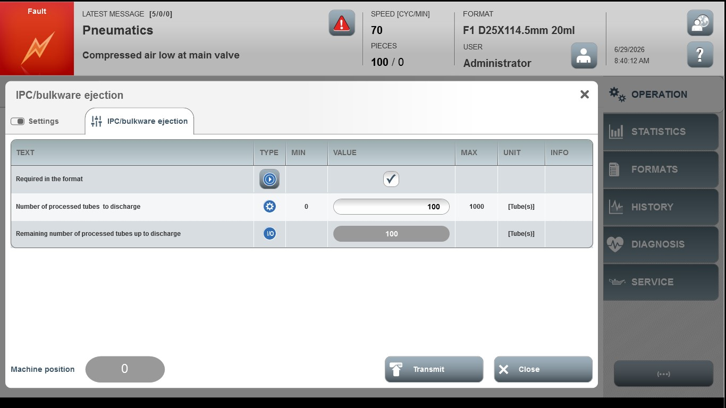
Acceptance criterion | Limits | Pass / Fail: Dev-No. | Date | Initials
Screen matches screenshot | N / A
Speed | 5 … 40

